**Simplilearn**

23

**Amazon Pantry**

**Course End Project**

**Prajwal Rawat**

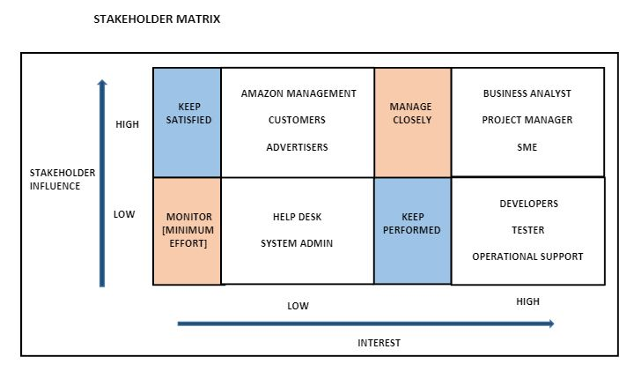

|  |  |
| --- | --- |
| **FUNCTIONAL REQUIREMENTS** | **NON-FUNCTIONAL REQUIREMENTS** |
| * Free delivery on order above 50 USD * New feature call ABC pantry into existing system * Essential and non-essential products can be added to the cart * Should be able to show five advertisements to earn the advertising revenues * Cannot check out if order value is less than 30 USD | * User friendly and self exploratory * New features are to maintained same as existing system * System should be secured against malicious threads. * System must have scalability to support large customer data. * System would perform fast and effectively for better ease of use. |

**CURRENT PROCESS FLOWCHART**

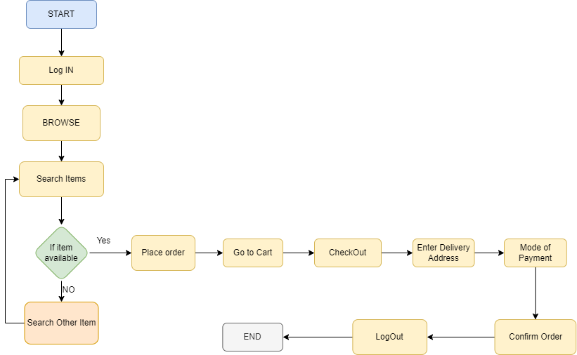

**FUTURE PROCESS FLOWCHART (ABC Pantry)**

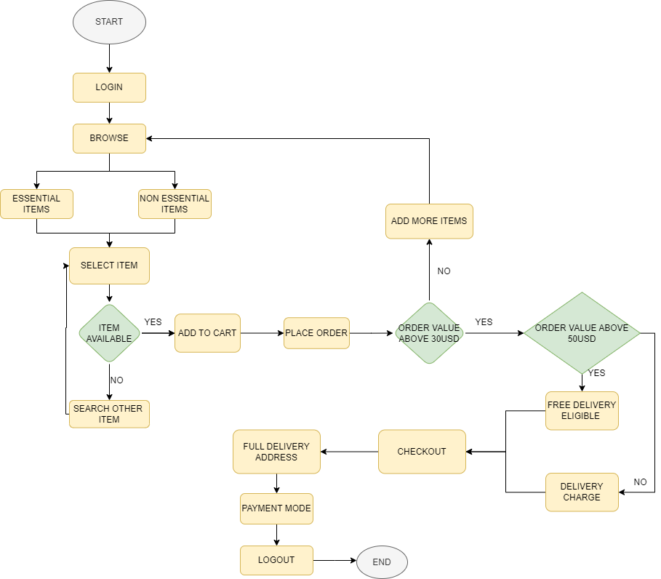

**CONTEXT DIAGRAM**

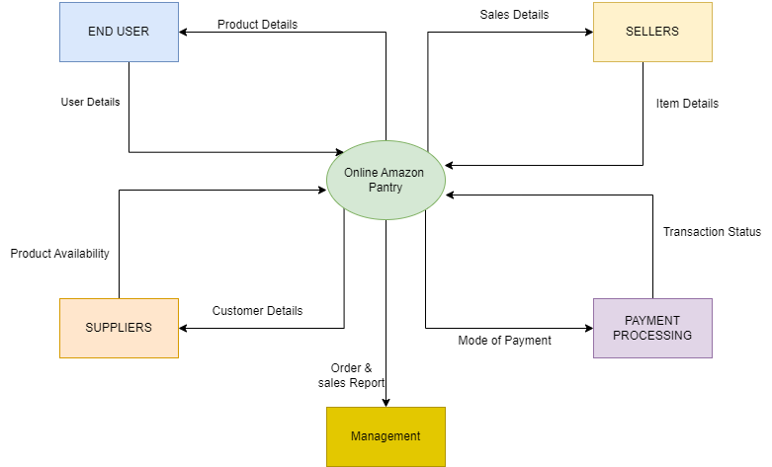

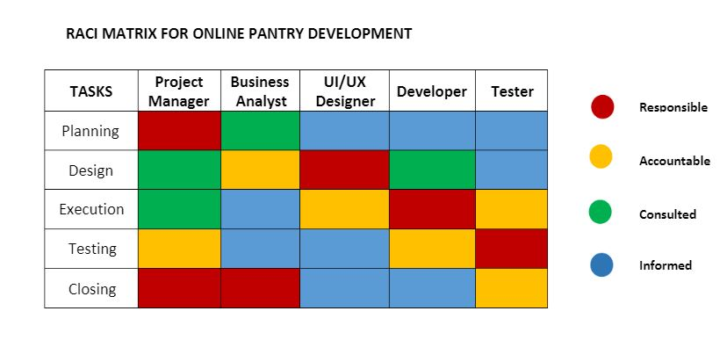

**Scope Diagram**

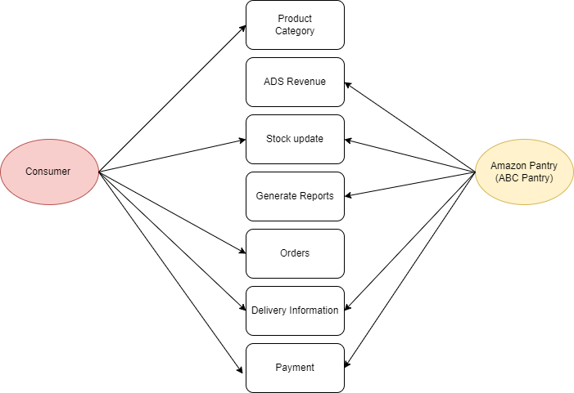

|  |  |
| --- | --- |
| **IN SCOPE REQUIREMENTS**   * Adding a new feature to the current system * Placement o feature in highly visible location * Status of product availability * Essential things and non essential items were both placed to the pantry * Deals/offers are available for both single products and combos * 5 advertisements are placed in a feature without being obtrusive * Orders above 50 USD are eligible for free delivery | **OUT SCOPE REQUIREMENSTS**   * Additional discounts are offered on specific goods. * Request for order cancellation/refund money * Direct contact to the supplier * Auto suggestion active for the products on pantry * Delivery of product must cost above 30USD * Portal’s option for expense prediction * Request for a certain delivery time/date * Subscriptions for further product discounts that are monthly or annually |

**WIREFRAME**

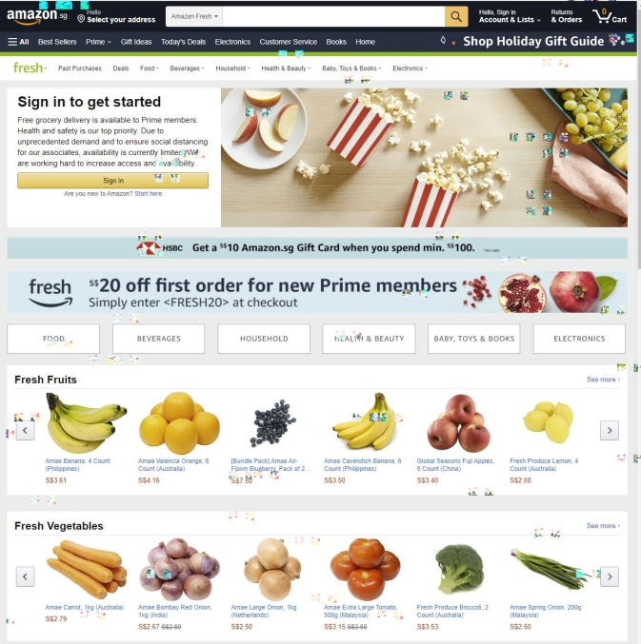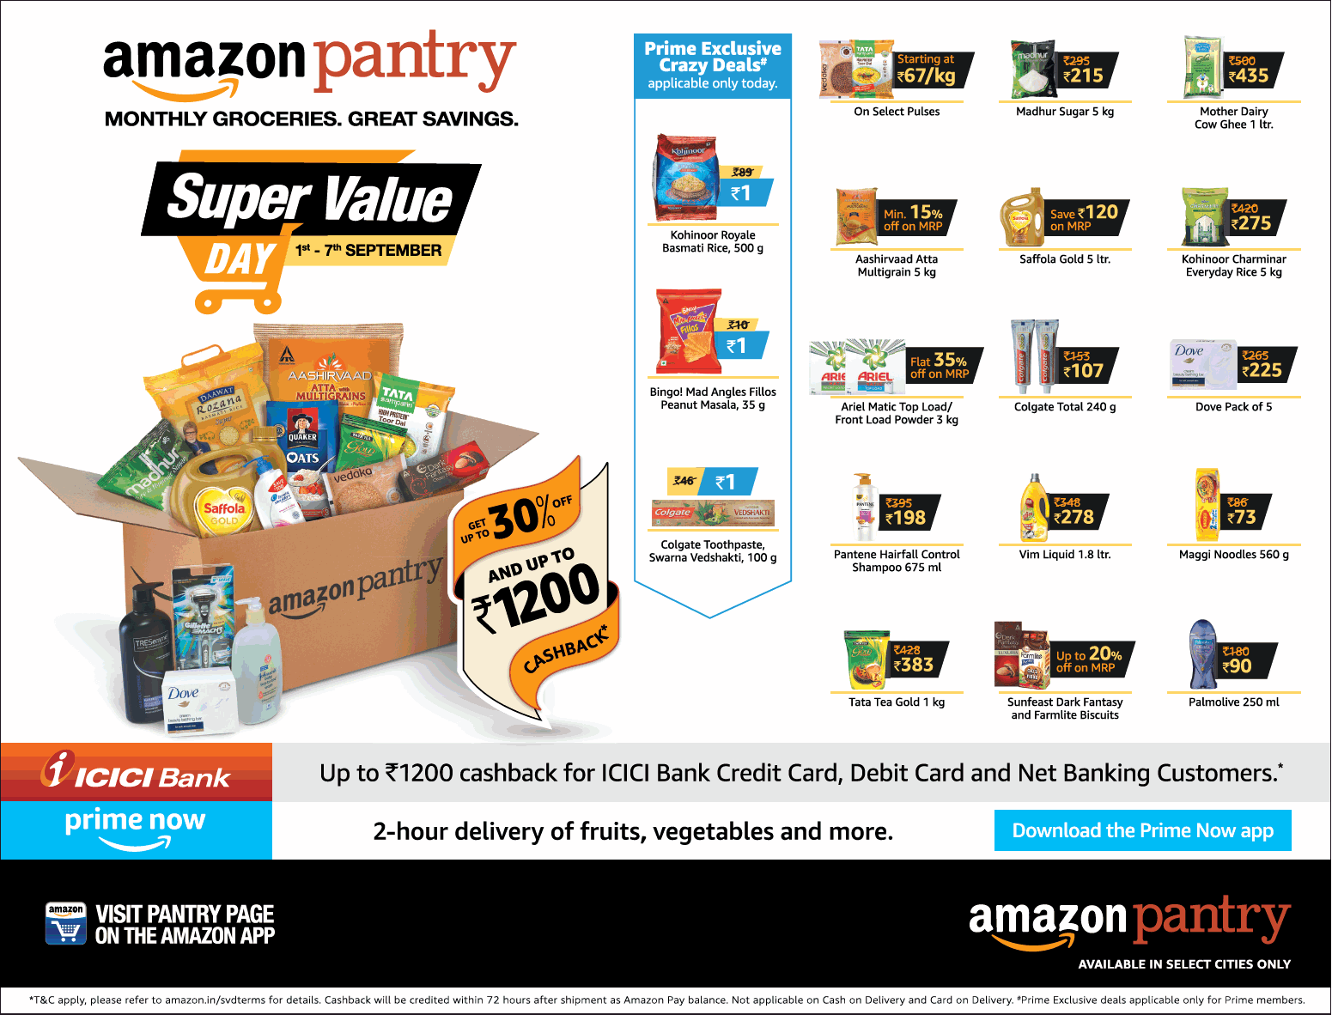

|  |
| --- |
| **Question 1**   1. Create a bar graph showing the sales. Label the chart correctly so that the senior managements get a clear report of sales. 2. Arrange the data above in excel in ascending and descending order. |

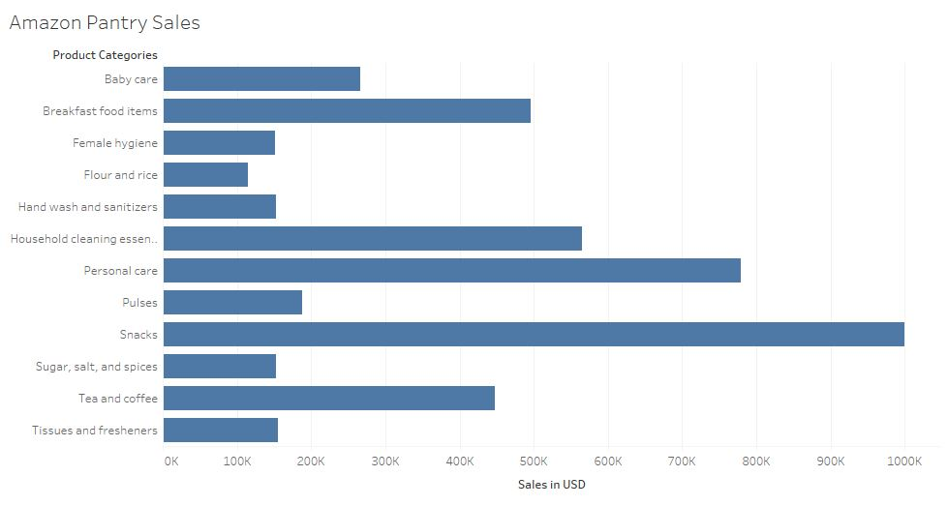

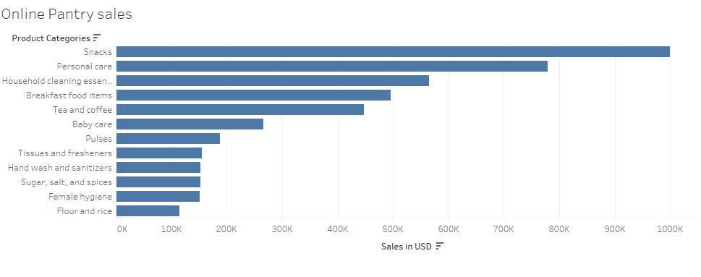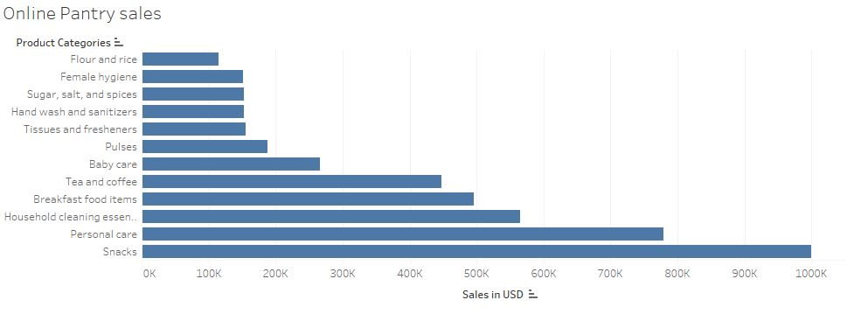

|  |
| --- |
| **Question 2**   1. Create a bar graph of sales for zone 1 cities. 2. Find total sales across all cities. |

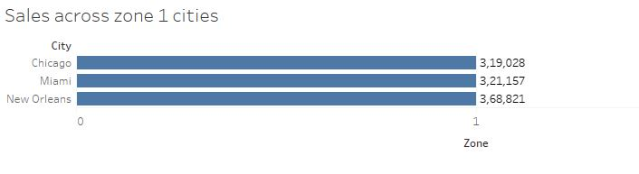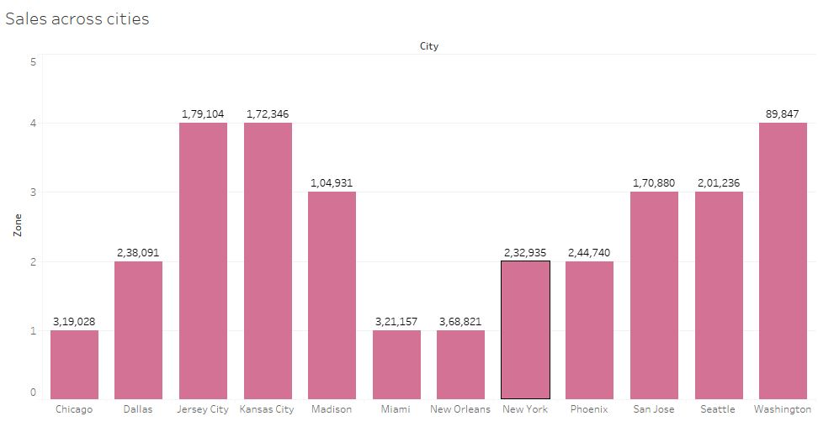

|  |
| --- |
| **Question 3**   1. Using VLOOKUP for product code HS, Find sales in Phoenix. 2. Using VLOOKUP for product code FS, Find sales in Dhallas |

